Down The Rabbit Hole – October/November 2013
Activity Summary

Four family-friendly events programmed as part of the nation-wide Family Arts Festival during October/November half term. We aimed to bring the gloriously creative minds from Watershed's Pervasive Media Studio to a family audience with a curious season of films and workshops perfect for all the family.

Alice In Wonderland + The Mad Hatter’s Magic Tea Party

Alice + The Big Draw Magic Ink Workshop

Rolling Stone Dance Workshop

Spellbinding Storytelling Workshop

http://www.watershed.co.uk/whatson/season/252/down-the-rabbit-hole/

Why

- Future Producer funding available
- BFI funding attached (for Magic Ink workshop)
- It was a great opportunity to bring the work of the PM Studio to a family audience
- It was a great opportunity to test the potential of the family market (we do have children’s activities at the moment)
- We knew we had good Cinekids base to build upon
- It was a key part of Future Producers activity which gave us extra resources and ideas

What & How:

- Created brand with appeal to family audience using Alice in Wonderland theme
- Arnolfini’s inhouse designer produced a joint piece of print (5,000?) (with other Bristol FAF organisations). Passport system like popular gromit print from summer.
- Distributed the print within building and had poster on noticeboard
- FPs distributed the print in residential areas in Bristol where family occupancy high (e.g. Southville and Bedminster area)
- Future Producers also contacted arts organisations in Bristol and surrounding area asking if they could share info on the events with their networks (online and with posters in house). We received very strong support on Twitter (e.g. Arts Council SW + Bristol Council Family Info tweeted about our events).
- First tier support on watershed.co.uk – front page/programme / intro /news post
- Emailed past attenders of the last Cinekids event
- Priced the events to appeal to target audience and make it an affordable family event (which we were able to do thanks to the funding we had).
- Produced and distributed feedback forms at every event.
- In house publicity: A0 poster in Café/bar, DCP, foyer screens, lcd screens, top-foyer screened showed front page
- Trailed it in the weekly email and then was the main intro piece for 3 of the weekly emails throughout its run. (25,000)
- Featured in monthly email. (1,113)
- Cover page for the weekly listings (2)
- PS on Arnolfini’s monthly email.
- Cross-promoted throughout Justin & The Knights of Valour run
- Listed on BFI Gothic page (Magic Ink event)
- Listed all events on FAF website
- News post and Press Release (written by FP)
- Events were picked up in Metro (UK), Metro (SW) and Bristol Post newspapers.

Spike Island @_SpikeIsland Oct 15
@wshed have some great events as part of the Family Arts Festival. Anyone for a magic tea party on Saturday? Watershed.co.uk/whatson/season…

In Between Time @In_Between_Time Oct 16
Go down the rabbit hole this weekend… @FamilyArtFest comes to @wshed & @PMStudioUK: ow.ly.pQ1VU #family #fun #Bristol

KWMC @knowlewestmedia Oct 16
Fantastic weekend of family films, storytelling & events with Alice in Wonderland theme coming up @wshed: ow.ly/pRSPq

Bristol Family Info @BristolFIS Oct 16
Sat 19 @wshed will be urious & amrvellous with Alice in Wonderland screened & then all kinds of magic, games & cake! Watershed.co.uk/whatson/4447/a…

Bristol Mum @bishopstonmum Oct 18 Lots of interesting activities for kids @wshed over the next cople of weeks watershed.co.uk/whatson/season….

ACE South West @ace_southwest Oct 25
A fascinating and surreal spin on lew’s Carrol’s classic @wshed TOMORROW bit.ly?H5mzi4 @FamilyArtFest #CYP #arts #culture

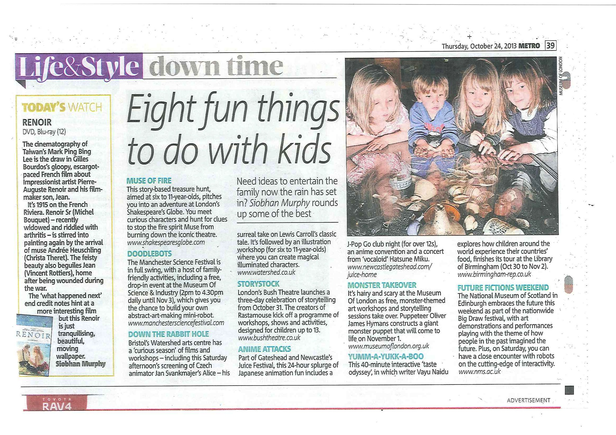

Metro, Thu 24 Oct, 8 fun things to do with the kids – Down The Rabbit Hole (Alice + Magic Ink Workshop)

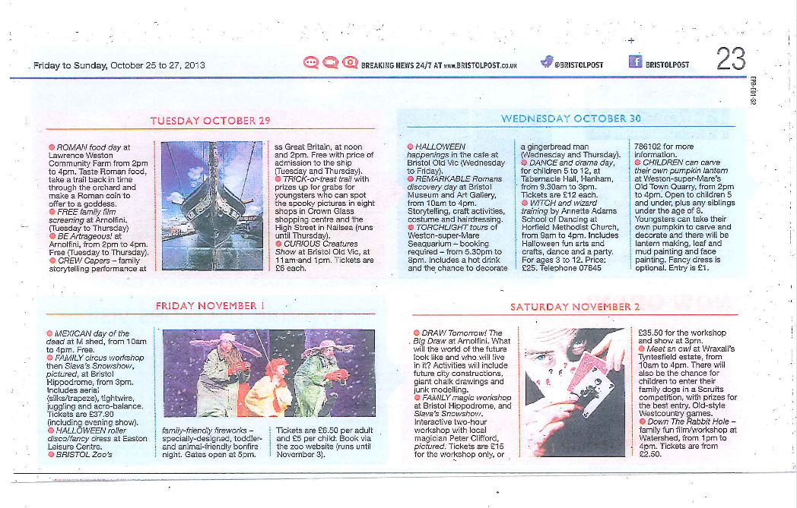
Bristol Post, Fri 25 - Sun 27 Oct – Sat 2 November – Spellbinding Storytelling
What worked?

An opportunity for us to target the family market (which is expanding) and also experiment with programming PM Studio events and artists for children’s activities.
It was also a good opportunity to work collaboratively on a strand of events with other arts organisations in Harbourside area, and be part of a national festival.

Box Office Sales

43% of the attenders who responded were new bookers

34% of bookers attended more than one event

80% of bookers bought their tickets in advance and 38% booked online

Having evaluation forms was also a really effective and has given us some great insight:

64% of attenders who left feedback said our events were brilliant, 32% said they were good, with 4% saying ok

44% of attenders who left feedback found out about the season on watershed.co.uk, 26% via weekly email, 4% through social media, 7% through FAF flyer and 7% by word of mouth, 7% Other.

71% of attenders were female and 29% male. Over 30% of the children who attended were 7 years old or under, and over 50% were 8 – 11 years old. Over 60% of adult attenders who left feedback were 35 – 44 years old and 10% of adult attenders were over 65+. 76% were in employment, 5% stay at home, 5% student and 14% retired.

What did we learn?

- We priced too low (especially for Tea Party event which included catering)
- Our core audience attended these events.
- The website is our strongest communication channel for family audience.
- Families are looking for things to do as a family during school holidays.
- To provide a range of activities for different age groups.
- That most families book tickets in advance and online.
- To be extra prepared when welcoming families into the organization and do good scenario-planning.
- That a launch event helps raise the profile of family season.
- That food and drink is goes down really well.

What do we want to do differently?

- Price confidently

- Have a longer lead-time to help with planning and implementation and spend some time on the PR opportunities.

- Give people more information in the lead up to the event: we will have a new Box office system for communicating before event and for follow-ups. Plan this interaction and do a break down of customer journey from minute they see exhibit online to leaving the building/aftercare to improve our family-friendliness. Can we get a family section of the website set up?

- Set targets to measure success against (e.g. number of attenders) and define what success look like when we continue experimenting.

