August 2021

Job title: Commis Chef (maternity cover)
Dear Applicant

Thank you for your interest in the above position. Please find enclosed a job description including person specification and terms and conditions of employment. Please consider these carefully and decide whether you wish to apply.
Before you apply
You may not have worked in a cultural organisation before, or in an organisation like Watershed. Perhaps you have worked in a hotel or coffee shop - which are very transferable contexts. If you are from a background that is underrepresented in the culture sector (for example you are from a community that experiences racism or you are a disabled person (as defined by the Equalities Act 2010), or you did not go to University or had free school meals as a child), and you would like support to articulate how your experience is transferable to this role, you can book time with us (we will ensure the person you meet is not involved in the recruitment process). They would be pleased to help you think this through. Please request this by emailing our HR Manager, Kirsty Young, on hr@watershed.co.uk (we will not ask you to disclose your background).
We believe our work will be stronger with greater diversity and welcome applications from those who bring balance to our team. Watershed welcomes the whole person to work, and we understand that each of us bring our experiences, our backgrounds and our own unique lens to what we do. Supporting our staff means they are not appointed to represent specific groups or organisations.
Timeline
The closing date for all applicants is: 5pm on Saturday 14 Aug.
We will contact all short-listed candidates by: 5pm on Sunday 15 Aug.
We will then hold interviews in the week beginning 16 Aug.
Please DO NOT include your CV as it will not be considered. Please put all relevant information on your application form.
We are striving to understand more about who applies to work with us. We invite you to complete our anonymous equal opportunities monitoring form, which will not be shared with anyone involved in the recruitment process.
Watershed will work with candidates to ensure their access needs are met during the interview process and will ensure access requirements do not factor in decision making.
Thank you for your interest in Watershed.
Chris Warren
Head Chef

Position: Commis Chef (maternity cover)
Contract: Full-time (maternity cover for 12 months or upon return of the permanent postholder)
Grade: 5
Responsible to: Head Chef
Purpose of Job
The post holder is responsible for food preparation, stock and portion control and maintaining excellent standards of health and safety, food hygiene, and customer service. You will be part of a team working under supervision of senior chefs to help maximise the business potential of the Catering operation.

Principal Responsibilities

- Prepare food for the Café/Bar and conference as required.
- Maintain kitchen areas and equipment to the highest standards of cleanliness and safety.
- Ensure food deliveries are handled and stored correctly.
- Work alongside all kitchen team members to ensure Company standards and good working relationships are maintained.
- Handover section and responsibilities of a shift to the next chef, observing hygiene standards.
- Close the kitchen area according to company specifications, when on late shift.
- Compliance with all hygiene and health and safety regulations concerning food and catering establishments.
- Actively support, encourage and have an awareness of general Watershed activities.
- Supervise the Kitchen Assistants and monitor progress of daily preparation and cleaning schedules.
- Any other duties that may be reasonably required.

Key Performance Indicators

  - Food for Café/Bar and conferences prepared to a high standard.
  - Kitchen areas are clean and safe at all times.
  - Systems regarding quality, portion control and minimising wastage maintained.
  - Food deliveries are handled appropriately in line with Company standards.
  - Health & Safety/Food hygiene standards maintained at all times.

Person Specification

Qualifications

- Recognised certificate or demonstrable knowledge of Health and Safety and Food Hygiene training.

Skills & Experience

- A team player and excellent communicator
- An understanding of cost control systems and their relation to financial targets.
- Food handling and preparation
- Previous experience in a customer focused environment.

Watershed Values
The Watershed brand is unique, trusted and respected and is driven by the following shared values which are clearly articulated. Ability to master and represent Watershed’s Vision and Values is therefore important.

Watershed is:
Inclusive | We are people led. We listen to and engage with the broadest range of people.
Open and Honest | We provide a culture and environment that is trusting, trusted and trustworthy.
Make Things Happen | We approach opportunity and challenge creatively, collaboratively and with a can do attitude.
Entrepreneurial | We are inventive, try new ideas, experiment, learn and share.
Celebratory | We celebrate culture, creativity and wonder.

Watershed encourages applications from people of all backgrounds but particularly encourages applications from candidates from a BAME background as they are currently under-represented within our staff team.

Additional information:

- The post-holder is expected to wear clothing appropriate to their post.

- The post-holder will be required to undertake such other comparable duties as may be required by the Head of Department'.
- Watershed is open seven days a week, including Bank Holidays (Christmas Day and Boxing Day are the only exceptions). Watershed is a public building, which operates a diverse range of cultural and commercial activities. The post holder will need to be comfortable working in this environment.
- Watershed is a COVID-secure environment working to Government guidelines to ensure that the workplace is safe for our employees
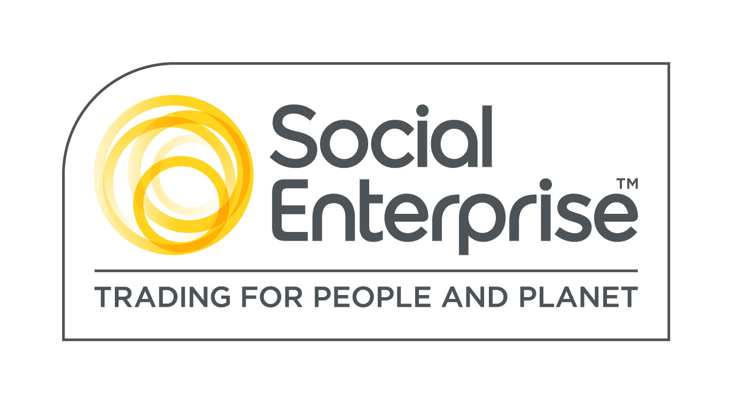
Watershed is a Social Enterprise Mark holder. Social Enterprises are businesses whose products and services create both social and environmental benefits.

